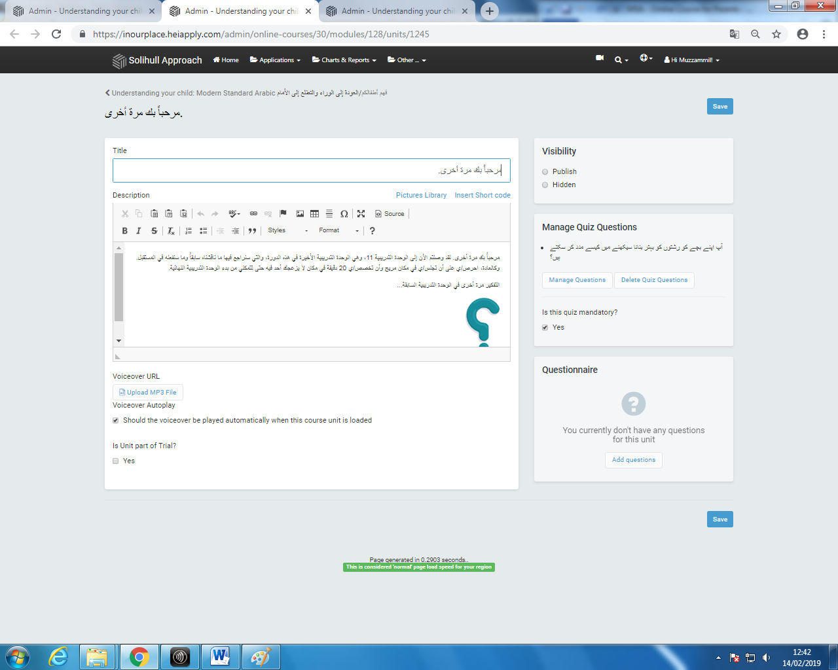
The Urdu text is still there and has not been overwritten by the amended Arabic Text it had been previously replaced with.
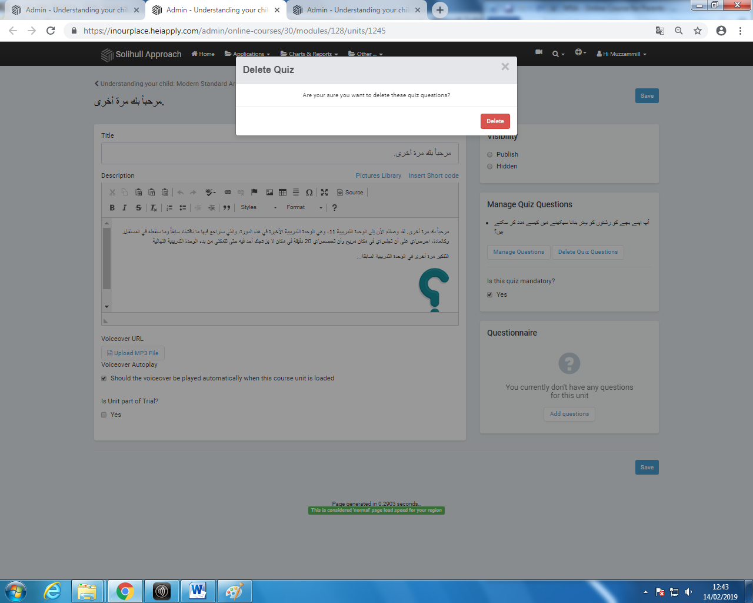
Arabic text does not show and Urdu text is not replaced by the Arabic unless quizzes are deleted first and the added again. This is the dialogue box/prompt when clicking ‘Delete Questions’.

This page shows after clicking ‘Delete’ on previous page (shown in previous picture). Reads: ‘File not found’.
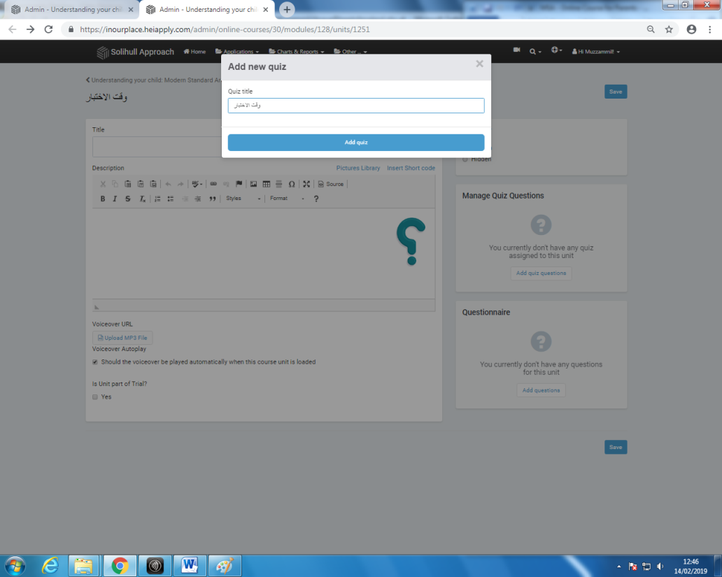
Clicking the ‘Back’ button and going back to the previous webpage brings up the unit content editor page again showing that the deletion and removal of the quiz questions was in fact successful but does not explain why the ‘File not found’ page appears. Picture shows the dialogue box/prompt when clicking ‘Add new questions’.

QUIZ QUESTIONS CAN BE ADDED AS NORMAL USING THE DROPDOWN.
Picture shows ‘File not found’ page once again appearing, however in this instance, it appears after clicking ‘Add quiz’ button (shown in previous picture).
HOWEVER ONCE SAVED AND PUBLISHED, NUMEROUS REPETITIONS OF THE SAME QUIZ QUESTIONS APPEAR.

